
DEPARTMENT OF

COMPUTER SCIENCE & ENGINEERING

Experiment: 1
Student Name: Ashmit Agrawal UID: 23BCS11854
Branch: B.E.- C.S.E. Section/Group: 23BCS_KRG-1A
Semester: 6 Date of Performance: 10-01-26
Subject Name: System Design Subject Code: 23CSH-314

- Aim: To design, develop, and analyze a basic URL shortening system that transforms long URLs into compact short URLs, and to evaluate its performance in terms of latency and throughput under different traffic loads.

Objective:
- To gain an understanding of how a URL shortening service operates internally.
- To build a working URL shortening and redirection mechanism.
- To evaluate system latency and throughput under simulated concurrent user requests.
- To analyze how architectural and design decisions affect non-functional performance metrics.

Requirements (Tools):
- Postman – for testing API endpoints
- Diagramming tools: draw.io, Excalidraw, Lucidchart
- Python libraries and frameworks (e.g., Flask)
- Procedure and Output:

Functional Requirements:

    - Given a long url => short url Premium user:
      - Custom url (optional)

      - Expiry date

    - Given a short url => redirect to the => long url

Non-functional requirements:

100 million daily active user => 1 million users are actually doing shorting of url

- Latency: 20ms (on url shortening, on url redirection)

- Availability: 24 x 7

- Consistency

- Scalability: Vertical or horizontal

- The generated short url -> always unique

Api design (url shorter):

Pre-defined functions:

- Get: Fetch some data from db.

- Post: When you want to insert some data into db.

- Put / Patch: Update

- Delete: Remove the data

Local host server: Https://127.0.0.1/shorten App.route(/)
- Post Api call - Req

{

Logic:

Url: "Long url " Custom url: "Custom" Expiry date:
}

Res:

{

Short_url: "Short url " Short_code: "123abc"
}

Https://127.0.0.1/123abc

- Get api call (</short_code?) Https://127.0.0.1/get_employee(empid)

Database schema design:

T1 user (id, name, phone etc.)

T2 url_mapping (id, longurl, shorturl, expiry date, customurl)

High Level Design:

Now according to the functional requirement of the system, we can identify that: There will be a client who is requesting, then there will a server upon which computation will be going on, and lastly there will be a database in which storage will be done.

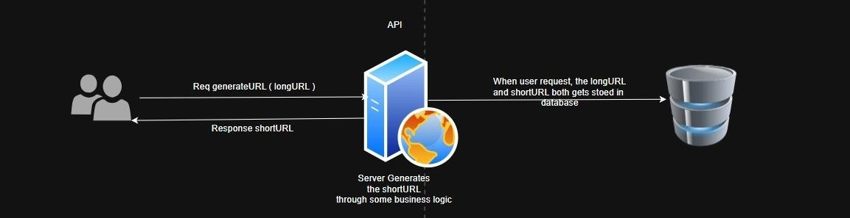
- shortURL Generation:

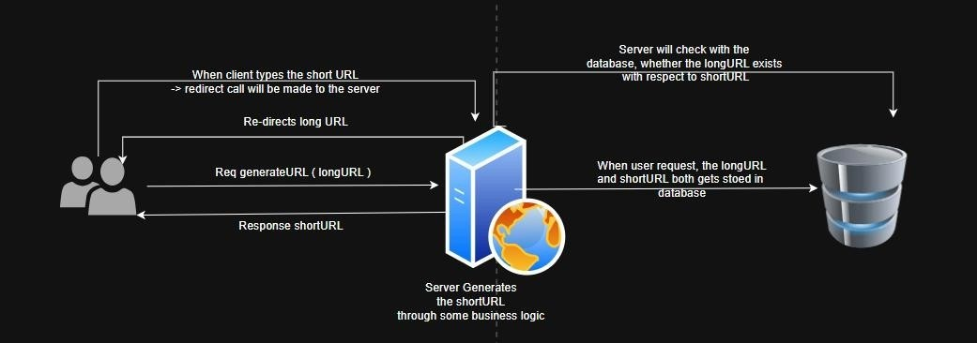
- Re-direction: When user enters shortURL in browser:

- We need to have REST APIs for client registration and login as well.

Low Level Design:

Now if you see in HLD we have only specified the specific things like the database, the server, but we haven't talked about:

- Which type of database is needed??

- Which type of server is needed and what sort of computation has been done inside the server.

Let's begin with the SERVER: how longURL is converted into shortURL longURL: https://www.amazon.com/rehan.products.catalog/orders/cart/payment
shortURL: https://bit.ly/5PLcymn

{5PLcymn} - shortened URL

LONGurl - BASE10 - LARGE STRING BASE 64 - HDGB25

Approach 01: Encryption
encrypt(longURL) = shortURL

Most Popular algorithm for encryption lib is: MD5, SHA1, BASE64 Problem

in this approach:
- Encrypted length is very large & the req was of short length url

- To resolve this, what we can do is we can take first 4 letters from encrypted text. But in this also a problem can occur.
Link 1: https://www.youtube.com/watch?v=HHUi8F_qAXM&t=1s06e2116c3e064129e81226fb7b5750 2c

Link 2: https://www.youtube.com/watch?v=jhjsdbi8793hch?2fdgv06e265f903040b075b90ed40ad15a4f6 e5a184a2

[both starting 4 char are same, pointing to same link in DB Duplication of links] Resolution:
At first, we can store the 4byte code & corresponding longURL in DB. Second time, if same 4byte code is generate, it will be compared in the DB, if code already exist -> again generate a MD5, 4byte unique code.

[This results into high latency issue = 16ms + 16ms] Possible Problems:
- Full table scan in database.

- More number of collisions

- These collisions will result into latency issue

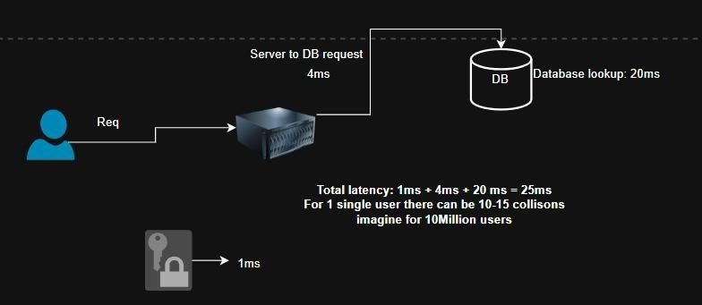

Approach 02: Counter Approach
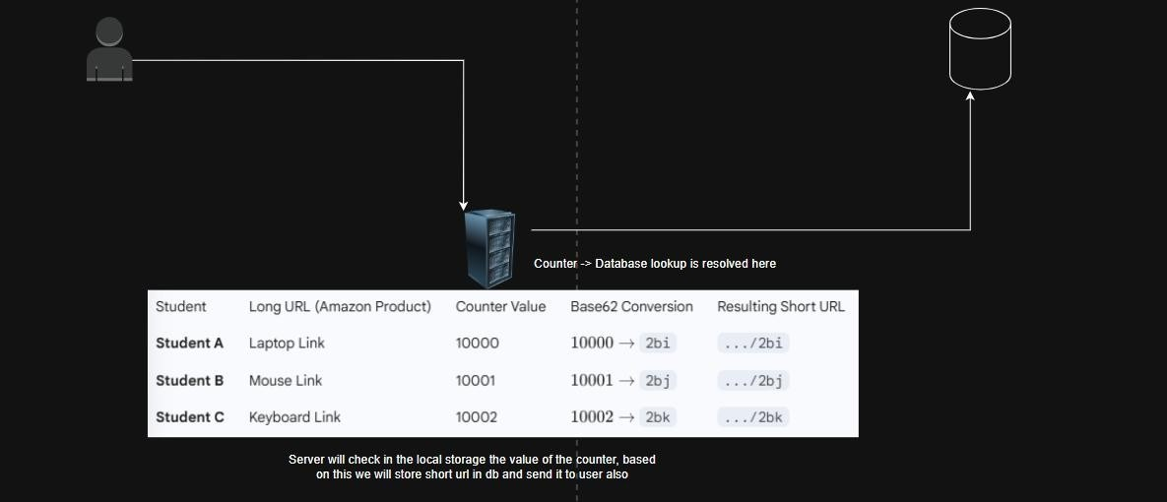
Problem with this approach:

Server follows monolithic architecture, it can process the request for 1 user easily by managing counter value, but what happens when 100 million user comes.

Resolution: Scaling

- Vertical scaling here is not possible as number of users are 100 M

- We will do the horizontal scaling over here



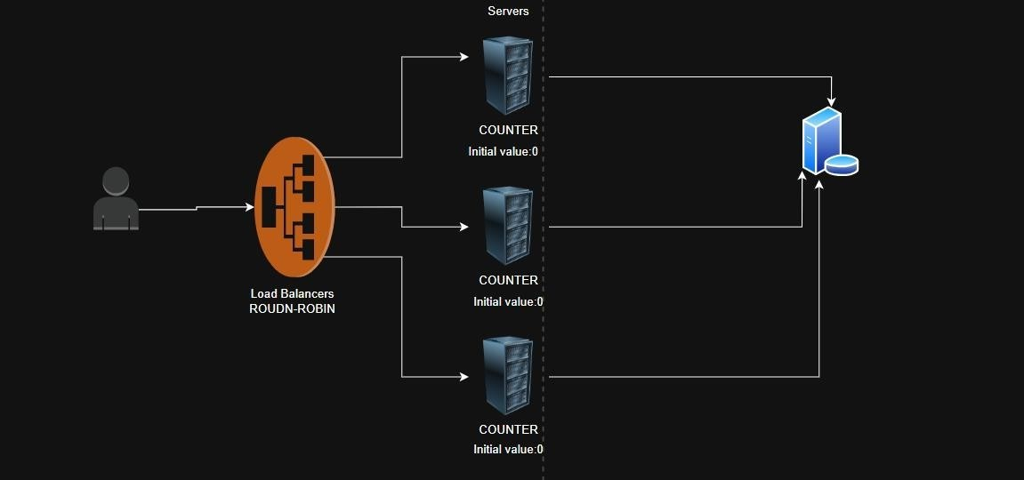

Problem:

Now in this method there can be a problem of dirty read that is server 1's counter may have some other value and server 2's counter may have some other value

Resolution:

Rather than storing the counter in the server itself, we can make the counter variable globally available using a CACHE

Final Low-level Design:
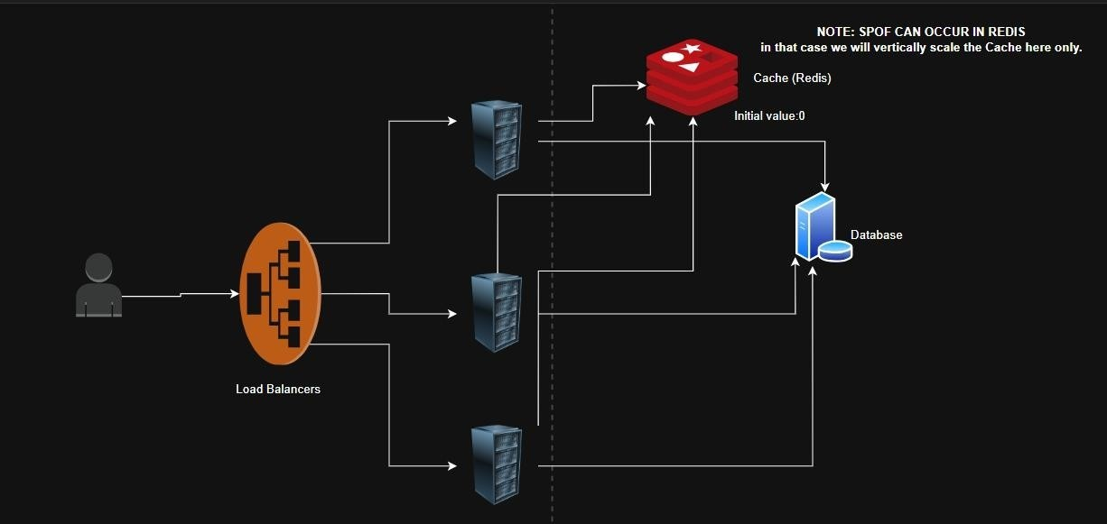

Learning Outcomes:
- Understood and differentiated functional and non-functional requirements for designing a URL shortener system.
- Designed and tested RESTful APIs for URL shortening and redirection using Flask and Postman.
- Created high-level and low-level system designs to ensure scalability, availability, and performance.
- Designed database schemas and implemented backend logic for URL mapping and user management.

